**KABARAK UNIVERSITY**

**SCHOOL OF COMPUTER SCIENCE AND BIOINFORMATICS**

**DEPARTMENT OF COMPUTER SCIENCE AND AUDIT**

PROJECT PROPASAL /RESEARCH PROJECT II

PROJECT PROPASAL TITLE: **ONE TIME PASSWORD EXAM CARD ISSUANCE AND VERIFICATION**

A Project Report Documentation submitted to the Institute of Undergraduate Studies and Research for partial fulfillment of the requirements for the Degree in Business Information Technology.

**VALERIA AKINYI: BBIT/MG/1441/09/20J**

**SUPERVISOR: Mr. CLEOPHAS MOCHOGE**

**MAY-AUGUST 2024**

# DECLARATION

I hereby declare that this research is my original work and has not been submitted to any other university or college for purpose of examination or academic award. Any information given in my entire work and all the relevant sources are quoted and acknowleged accordingly.

BBIT/MG/1441/09/19

VALERIA AKINYI

Signature………………………..Date…………………..

# RECOMMENDATION

This research proposal entitled ONE TIME PASSWORD EXAM CARD ISSUANCE AND VERIFICATION and written by Valeria Akinyi is presented to the school of Business and Economics of Kabarak University.We have reviewed this proposal and recommended it be accepted in partial fulfillment of the requirements for the degree of Information Technology.

Department of Computer Science and Information Technology

Mr. Cleophas Mochoge

Signature……………………………. Date………………………

# DEDICATION

This piece of work is dedicated to my parents for their continous support, guidance and advice through my life and education and to my coursemates for the motivation and encouragement through this study.

# ACKNOWLEDGEMENT

I praise God for the gift of life, family, friends and provision without which I would not have made it this far in my academic pursuits. All glory and honour to the Almighty.

Many special thanks to my lecturers and supervisor Mr. Wyclef Ayako for their guidance and patience throughout my studies. Your wise counsel and input during my research have made it possible.

# ABSTRACT

With the current technology trends, almost all documents are digitally packaged, due to university need to adapt to ever-evolving technology. The One Time Password(OTP) generation for exam card system was established as an essential proof that would enable the candidate to carry out the final exam with provisions to verify student identity. However practically, most University Student Exam Card sheet distribution in Kenya still adopt the traditional nature of queues. This will cause problems in case the exam card can be lost or damaged alongside the charges incurred to initially print and replace the lost exam cards and student identity cards. The queue system is also time consuming hence not convenient enough. The research led to the implementation of an innovative OTP Exam Card Issuance and Verification (OEIV) system focused on the efficient issuance of examination cards within higher learning institutions in Kenya, verification of the exam requirements including the student identities and serialization of exam booklets to ensure transparency during examinations. Information Technology can widely be used to improve the world of education, especially by systematically and digitally storing student details such as exam details and images on secure websites. An OTP Exam Card issuance and verification system was designed to offer Services that can make it easier for Kabarak University students to have their examination details and identities verified through the system (OEIV) at the exam halls by just printing and presenting a secure code provided by the examination administrators. To achieve this solution, an integration of advanced technologies, including secure OTP based authentication mechanisms, and database management systems was incorporated into the system. The OTP based authentication was designed to enable swift verification of students' identities by displaying the relevant student exam details including images from the system providing extra layer security and validation. Additionally, the system was designed to utilize advanced database management techniques to accurately link student profiles with their respective examination units, ensuring that the information displayed is both precise and up-to-date. Since an exam portal was required for this system, the development was split into front end and back end, python and Django framework was used for front end and back end development respectively in presence of APIs to communicate between the different frameworks. This research was meant to transform the examination management system efficiency, reduce queues, and implement physical distancing during a pandemic. In conclusion, the research lead to development and implementation of a system that significantly improved the efficiency, accuracy, and reliability of the examination card issuance process. By streamlining these administrative tasks, the system was equally designed to enhance the overall experience for both students and educational institutions, which reduced errors, delays, and administrative burdens associated with the distribution of examination cards.

Keywords: *OTP*, *Exam cards, verification, identity, examinations*

# Table of Contents

DECLARATION ii

RECOMMENDATION iii

DEDICATION iv

ACKNOWLEDGEMENT v

ABSTRACT vi

Table of Contents vii

CHAPTER ONE 1

INTRODUCTION 1

1.0 INTRODUCTION 1

1.1 BACKGROUND OF THE STUDY 1

1.3 PROBLEM STATEMENT 2

1.4 GENERAL OBJECTIVE 2

1.4.3 SPECIFIC OBJECTIVES 3

1.5 RESEARCH QUESTIONS 3

1.6 SIGNIFICANCE OF THE STUDY 3

This study has benefited several groups of people, including: 3

Feasibility study 4

I. Technical Feasibility: 4

II. Economic Feasibility: 5

III. Legal Feasibility: 5

IV. Operational Feasibility: 5

V. Market Feasibility: 5

Scope and limitation of the study: 5

Other limitations of the study include: 6

CHAPTER TWO 7

LITERATURE REVIEW 7

2.1 EXAM CARD ISSUANCE AND STUDENT IDENTITY 7

2.1.1 Examination Eligibility Verification 7

2.1.2 Challenges of traditional examination approach 7

2.2 DATA RETRIEVAL 8

2.2.1 Retrieval of student Information via Code 8

2.3 OTP EXAM CARD ISSUANCE AND VERIFICATION SYSTEM 8

2.3.1 Eligibility 8

2.3.2 Advantages of OTP 8

2.4 RELATED WORKS 9

2.4.2 STUDENT ATTENDANCE SYSTEM 9

2.4.3 QR CODE STUDENT EXAM SYSTEM BASED ON ATTENDANCE 10

2.4.5 QR BASED SYSTEM IN EXAMINATIONS 11

CONCEPT MAP 13

CHAPTER THREE 14

RESEARCH METHODOLOGY 14

3.0 INTRODUCTION 14

3.3 RESEARCH METHODOLOGY 14

3.3.1 Six Stages of the Waterfall Software Development Life Cycle 15

*Figure 2* 15

3.3.3 Justification 16

3.3.4 Conclusion 16

3.2 DATA COLLECTION 17

3.4 TESTING 18

3.4.1 Heuristic Evaluation 18

DESIGN DIAGRAMS 19

3.5 Context Diagram 19

3.5.1 DATA FLOW DIAGRAM 20

3.5.3 RESEARCH ETHICS 22

CHAPTER FOUR 24

4.1. Introduction 24

4.2. System Architecture 24

4.3. Front End Development (code extract) 25

4.4. User Interface Design 28

4.5. User Interface Modules (screen shot &explanation 29

4.6. Back End Development 31

3.1.1 Database Design Modules 33

3.1.3 Code Testing 34

I. User Acceptance Testing 34

II. Scenario-Based Testing 34

III. Security Testing 34

IV. Performance Testing 34

V. Acceptability Testing 34

VI. Cross Platform Testing 35

VII. Automated Testing 35

3.1.4 Deployment Methods 35

CHAPTER FIVE 38

Conclusion and future work 38

Conclusion 38

REFERENCES 39

APPENDICES 41

**Table of Figures**

**Figure 1.** Concept Map 11

**Figure 2.** Water Fall Model 13

**Figure 3.** Context Diagram 16

**Figure 4.** Data Flow Diagram 17

**Figure 5.** Use Case Diagram 18

**Figure 6.** Exam Card Diagram 18

**Figure 7.** Exam Card Diagram 18

**Figure 8.** Exam Card Diagram 18

**Figure 9.** Registration Form Diagram 18

**Figure 10.** Exam Admin Dashboard Diagram 18

**Figure 11.** Student Dashboard Diagram 18

**Figure 12.** Lecturer Dashboard Diagram 18

**Figure 13.** Back-End Model Diagram 18

**Figure 14.** Student ID Diagram 18

**Figure 15.** Diagram 18

**Figure 16.** Registration Diagram 18

# CHAPTER ONE

# INTRODUCTION

# INTRODUCTION

The problem of "ghosting student syndrome" or exam cheating, has been a big deal for schools and colleges. They had to make sure that the people taking exams were actually the students who were supposed to be there. One way they tried to fix this was by using fancier ways to check who was who during exams. They looked at things like fingerprints or faces to make sure it was really the right student taking the test. Another idea was to use more than one way to check someone's identity. So, students might have to show their ID card, use their fingerprint, and type in a special code. Some people even tried using something called block chain to keep track of who was allowed to take the test. It was like a super-secure digital list of students. But all these ideas needed to be practical and not cost too much, hence the consideration of the above failed solutions led to the designing and implementation of the OTP code generation to curb for the examination malpractices.

1. Top of Form
2. Bottom of Form

# 1.1 **BACKGROUND OF THE STUDY**

Final Semester Examinations are routines for every semester, in all the Faculties of Kabarak university. Examination certainly requires authentication for students, it is usually done by showing exam and student identity cards. The exam cards can only be obtained if students have registered and paid for the exam. The issue remains on the method used for the distribution of these exam cards to students and thereafter the verification of their identities when approaching the exam halls.

At every final semester exam implementation, there are still queues of students who have already registered and paid for exams at the respective examination departments of various schools at Kabarak university to collect exam cards. This queue creates crowds of students at the school departments causing the Administrative department to print the cards and the Front Office staff to be overwhelmed in printing and distributing test cards to students. To avoid crowds in queues for taking the exam card, it is necessary to design an information system(OEIV) that can allow exam administrators to generate code to students, the student can then print the codes and present them to invigilators/lecturers at the exam entrance hall. The code is supposed to retrieve the image of the student for identity verification and display relevant examinations details such as the units registered and other examination details only for students who have

Traditional examination management systems often face challenges related to identity verification, including the risk of impersonation and the manual distribution of course unit information. A comprehensive solution is required to address these issues and enhance the overall examination process.

## 1.3 PROBLEM STATEMENT

The lack of a secure, efficient and technologically advanced system to manage examination processes for higher learning institutions in Kenya which had led to an inefficient and time-consuming process for learners or students to physically attend various departments during the last days of examination preparations just to queue lines and obtain a printed examination card to be used as an indicator for the respective registered units to be taken during the end of semester examination. This is approach seemed was time consuming and very inefficient and inconvenient especially for the less privileged students who were completing their fee payments just few days to examinations.

This problem led to the development and implementation of a system that was significantly any designed to improves the efficiency, accuracy, and reliability of the examination card issuance process, offering features such as image storage for secure identity verification, image retrieval via secure code dynamic course unit display, Real-time database integration and encryption and data security.

## 1.4 GENERAL OBJECTIVE

To develop a secure, efficient and most accurate OTP Exam Card Issuance and Verification System that retrieves student image for identity verification via code and dynamically displays relevant units to be taken.

# 1.4.3 SPECIFIC OBJECTIVES

1. To investigate the current learning institutions and understand the challenges of current approach in distribution of exam cards and verification of student identities within three months.
2. To design a user-friendly platform that will reduce cases of impersonation during exams by 50% every semester.
3. To implement OTP exam card issuance and verification system by assessing the required resource, technology and personnel required for successful implementation within three months.

# 1.5 RESEARCH QUESTIONS

1. What are the challenges facing the traditional/current examination approach in distribution of exam cards and verification of student identities?
2. What models can be used to design a user-friendly platform that retrieves student uploaded image via code and uses the same code to displays relevant units to be taken?
3. How can the OTP Exam Card Issuance and Verification System be implemented?

# 1.6 SIGNIFICANCE OF THE STUDY

The study has streamlined the process of exam card distributions to candidates and eradicated impersonation issues which were experienced during examination sessions in Kenyan higher learning institutions. It has provided a user-friendly platform that has helped streamline the process of accessing relevant student examination details in a secured web based environment and retrieving student’s images from the system. The system has made it easier for administrators to upload student images and retrieve them for identity verification when need arises.

# This study has benefited several groups of people, including:

1. **Institutions**: many higher learning institutions in Kenya have benefited from the OTP Exam Card Issuance and Verification System by having a more efficient, accurate and time saving method of distributing exam cards to candidates. With the unique feature of student image retrieval from the system adding an advantage to verify students for legitimacy and prevent impersonation – a disease that was been affecting the examination process for ages.
2. **Students**: learners in the education industry have majorly benefited from the (OEIV) system. They now have access to a more efficient and simplified process of accessing their exam card during examination sessions. The ability to do away with line queues especially during pandemic periods such as the COVID -19, is an advantages to them. Similarly, students will not be required to pay fees for applying for the student identity cards and having to replace them at a fee in case of displacement.
3. **Education sector**: Security and Integrity of Examinations. An OTP Exam Card Issuance and Verification System has ensured that only eligible and registered students are be allowed to take exams. This has helped maintain the integrity and security of the examination process. Also, student identity verification through image retrieval has been used to curb and reduce instances of impersonation, cheating, or other fraudulent activities during exams.
4. **Research Community:** The research community has benefited from the findings of this study, which will contribute to the development of more efficient and effective examination management systems for developers in other regions of the world in the coming future.

Overall, this research proposal has addressed a significant gap in the Kenyan education industry, with the goal of improving the efficiency of the examination process in higher learning institutions in Kenya. The study has benefited institutions, students, the education industry, and the research community.

## Feasibility study

## Technical Feasibility:

The implemented OTP exam card issuance and identity verification system turned out to be is technically feasible, as it was built using modern web technologies and hosted on a secure and reliable web hosting platform. The required technical skills obtained through hiring a team of experienced developers or outsourcing the development to a reputable system development company.

## Economic Feasibility:

The availability of funds economic made the OTP Exam Card Issuance and Verification System economically feasible the funds covered for development, marketing, and ongoing maintenance costs. The system was designed to generate revenue through purchases made by institutions. A comprehensive business plan was used to assess the financial viability of the project.

## Legal Feasibility:

The OTP Exam Card Issuance and Verification System was designed in compliance with all applicable laws and regulations in Kenya, including labor laws, data protection laws, and tax laws. Appropriate legal agreements and contracts were put in place which ensured the rights and responsibilities of all parties involved were clearly defined.

## Operational Feasibility:

The OTP Exam Card Issuance and Verification System was operated by a small team of employees or contractors who ensured management of the day-to-day operations, including customer support, system maintenance, and marketing activities. A comprehensive operational plan was created to ensure the smooth running of the system.

## Market Feasibility:

The OTP Exam Card Issuance and Verification System addressed a significant gap in the Kenyan education sector by improving the efficiency in the distribution of exam cards and verification of student identities for institutions. Market research were conducted to determine the potential demand for the system and to identify any competitors or similar platforms operating in the region.

## Scope and limitation of the study:

The scope of this study involved the development of an OTP Exam Card Issuance and Verification System for higher learning institutions in Kenya, which improved the efficiency of the examination process through provision of a user-friendly platform that streamlined the process of distributing examination cards to learners and enabled verification of identities within the same system. The study also focused on the target group of institution and examination service providers in Kenya, as well as students in the Kenyan higher learning institutions who required the services to be offered by the system.

The study was limited to the development of a web-based platform, and was designed to be accessible to all the relevant users via the internet. Similarly, it was designed to be responsive and accessible on various devices, including desktop and laptop computers, tablets, and mobile phones.

Lastly, the study was limited to address the broader issues affecting the examination processes in the Kenyan higher learning Institutions outside of the development of the OTP Exam Card Issuance and Verification System. Additionally, the study was limited to the geographical area of Kenya, hence the findings may not be directly applicable to other regions or countries.

## Other limitations of the study include:

**Time constraints:** The study was limited by the time available for research, development, and testing of the OTP Exam Card Issuance and Verification System.

**Resource limitations**: The study was limited by the availability of resources, including funding, personnel, and technology available to develop the OTP Exam Card Issuance and Verification System.

**Data limitations**: The study was limited by the availability and accuracy of data related to the previous developments on examination systems used in various higher learning institution Kenya.

Despite these limitations, the study has made a significant contribution to the Kenyan educational fields especially the examination field for higher learning institutions by improving and providing an efficient and streamlined approach on how exam cards will be distributed and verify student images during exam sessions, ultimately benefiting developers, clients, and the education sector as a whole.

# CHAPTER TWO

# LITERATURE REVIEW

This chapter contains comprehensive literature review drawn from theories and past studies related to the study on OTP exam card Issuance System narrowing down to the education sector and whether these studies are necessary and justifiable. The literature review will look into the purposes of technology to the examination department and how it promotes the efficiency and reliability of universities

# 2.1 EXAM CARD ISSUANCE AND STUDENT IDENTITY

## 2.1.1 Examination Eligibility Verification

Recently, impersonation is being experienced every now and then in examination centers; the ghost student syndrome that has become a threat across all levels of education is often referred to as examination malpractice. In education, an examination is a formal test intended to measure the knowledge, skill, aptitude, proficiency, or ability of a candidate in a subject/course. Therefore, it is a service. At this information age, whoever who wants to authenticate use a service must have a means of verifying his/her eligibility/identifications for example, identity card, ATM card, driving license, health care card, etc. Examination as a service is not an exception. Nowadays, in many institutions of higher learning, during an examination the only method invigilators and security personnel use to verify eligibility of a student is through checking his/her identity card to know. whether he/she is registered or not.

## 2.1.2 Challenges of traditional examination approach

Consequently, some students may not write their examination or test personally, especially for courses that they perceived as “difficult”. Therefore, they may hire or request for help from a registered higher-level student or another student in a different department that is well learned in the course. This is impersonation and consequently examination malpractice. This becomes possible because only ID card is used to identify and verify registered students. However, using only ID card for verification does not show whether a student has registered for a course or not. As a result, some students make use of this loophole to request the assistance of other students from another level or other department to help them write the examination on their behalf. Furthermore, in some universities, each student is issued an examination card, which consist of the registered courses for that semester/session. In some cases, when they are not given an examination card, the student is informed to come along with their course registration forms. This consumes a lot of time and is stressful. It also gives the students an opportunity to write words that could be helpful in examination.

# 2.2 DATA RETRIEVAL

## 2.2.1 Retrieval of student Information via Code

The idea of an OTP was first suggested by (Lamport, 1980). Nowadays, there are many patented OTP tokens. The method of delivering the OTP may be a proprietary token, via mobile phone, on paper or a web-based approach. A few standards have been developed to facilitate adoption of OTP authentication by enabling interoperability across commercial and open-source implementations for a better user experience. The first step of OTP technology is OTP calculation, which is the algorithm to generate a unique passcode for every authentication

# 2.3 OTP EXAM CARD ISSUANCE AND VERIFICATION SYSTEM

## 2.3.1 Eligibility

The proposed system using One Time Password is a web based application, which is resourceful in giving an effective and reliable verification of student's eligibility over the existing system as second level authentication. The system involves two parties: Student and Invigilator. On one hand, every registered student have the code sent to their emails. On the other hand, the lecturer has a smartphone logged into the system and thus when the code is verified it reflects the exam card details i.e units to be done and the students’ image for this purpose, the system is divided into two phases enrolment and verification. In the first phase, each student is enrolled by registering his/her personal details and photograph. While in the second phase, invigilator and/or security personnel verifies each student’s eligibility.

## 2.3.2 Advantages of OTP

**Defense against replay attacks and forced delay attacks**

A replay attack is a kind of impersonation or other deception involving use of information from a single previous protocol execution, on the same or a different verifier (Zaman, 2000). A forced delay occurs when an adversary intercepts a message and relays it at some later point in time. Unlike a fixed password scheme, a one-time password system prevents replay attacks. In such OTP authentication system, OTPs value by keyboard input and crossing the network were used only once, so replay attacks – whether shoulder surfing, keyboard logging Trojans, or network eavesdropping – become useless. Time stamps, also used in our system, allowed the detection of forced delay attacks.

**Ease of use.**

Our OTP authentication prototype for mobile phones has the advantages of simple one-pass authentication message exchange, no need for a third party, low computation cost and lower financial costs than proprietary tokens.

**Vulnerability of the mobile phone.**

Our prototype for mobile phones is vulnerable to keyboard monitor attacks, memory scan attacks and software clone attacks, because of mobile phone’s limited resources.

# 2.4 RELATED WORKS

**2.4.1 ENHANCED SECURITY FOR ONLINE EXAMS USING GROUP CRYPTOGRAPHY**

Jung and Yeom (2009) Studied the possible ways to take the online exam without having proctor supervision. The authors have discussed in detail the common cheating scenario that is adopted by the students, and how to prevent the students from cheating. They have suggested some techniques for developing an online testing plan and some online exam control procedures such as taking exams at one set time, using Respondus Lockdown Browser (RDL), verifying student ID, and so on.

## 2.4.2 STUDENT ATTENDANCE SYSTEM

Subramanian, Hassan, and Widyarto (2013) proposed barcode scanner based Student Attendance System (SAS) to replace the manual attendance record system with the bar code scanner technology in order to record and regulate the student attendance records more efficiently and effectively. According to the researchers, in the bar code scanner technology, each student will be given a student card for each of them with the bar code displayed on the card for a scanning purpose every time he/she attends a class. A student attendance status will be recorded into the system once a lecturer scans a student card with bar code scanner automatically. This shows that the attendance system using bar code scanner technology is much better than the traditional attendance system in school as a lecturer just requires to scan the bar code on the student cards as a proof that the student attended the class. More so, the system allows the administrator to generate warning letters if a student does not meet the attendance requirements, however, the generated warning letters will be given to each default student for onward delivery to his/her parent without giving a Short Message Service (SMS) or email to the parent. Therefore, there is every possibility that some students may throw away the letter without handing it over to their parents. Since the letter is not a good news on their part. Jacksi, Mohammed, and Zebari (2018) proposed a Student Attendace Management System. The system was designed to designed student’s activity in the class by taking attendance electronically and storing the records in a database.

## 2.4.3 QR CODE STUDENT EXAM SYSTEM BASED ON ATTENDANCE

Kinjal and Hiren (2014) proposed a student attendance system based on QR code using smartphones to fast track the process of taking attendance by University instructor. The system requires a simple login procedure by the class instructor through its Server Module to create an encoded QR code with exact information. This can be done at any time before the class. During the class, or at its beginning, the instructor displays an encoded QR code to the students. The students can then scan the revealed QR code using the system Mobile Module, provided to them through the smartphone market by the university. Along with the student's facial image taken by the mobile application at the time of the scan, the Mobile Module will then communicate the information collected to the Server Module to confirm attendance. The proposed system allows fraud detection based on the GPS locations as well as the facial images taken for each student. However, precious time is being lost during the period, instead of the lecturer to lecture the student they tend to use the period to take their attendance.

**2.4.4 OTP BASED ELECTRONIC PROTECTION SYSTEM FOR EXAM PAPER LEAKAGE**

Saidivya and Bhargavi (2014) proposed an OTP based electronic system. The system was designed to provide secure access to exam papers to only authorized personnel, such as teachers and invigilators. The OTP based electronic protection system consists of two main components: the server and the client. The server generates and manages the OTPs, while the client is responsible for receiving and verifying the OTPs.

## 2.4.5 QR BASED SYSTEM IN EXAMINATIONS

(Falguni, 2015) proposed QR code approach for examination process. QR code reader via camera device in mobile phones is used to automate examination process. This proposed system is appropriate for objective examination and also have Multiple Choice Question (MCQ), True/False and extended matching variety. Teachers have to register on the examination server so that they can create objective type of question paper. After encoding it then server creates QR code for matching question paper. The students are expected to have Android mobile phone and must be able to send and receive data when linked to Wi-Fi range. Students are instructed to scan the QR code using their mobile phone once so that they will be able to see the examination question to be taken. This proposed system focuses on the objective part of an examination neglecting the essay part of an exam. The system is not viable because to prevent malpractices during exams the student cannot be allowed to have their mobile phones. Hence need to developed the new proposed system (OEIV). Adsul, Kumbhar, and Bankar (2014) proposed a system of two-dimensional (2D) barcodes with the capability of storing data, to assist in reducing the action of hardcopy for exams. Currently exam conduction is predominantly paper based. This paper provides idea about generating QR code containing (MCQ) questions which can be viewed by students. The QR code can be decoded by the students on their mobile handset, after which the questions can appear on their mobile screen. After answering the questions in a stipulated time period, answers can be sent to the server. The result is calculated on the server and displayed. This paper proposes a QR Code based examination system to automate this process. This work proposes uses of two-dimensional (2D) barcodes, which has the capability of storing data, to assist in reducing the action of hardcopy for exams. Malpractices can be put to an end. Shah and shah (2017) proposed a Secure Examination System using Biometric and QR code Technology to efficiently manage examination conduction in more systematic and secure manner and keep personal information like name, class, division and roll number of student hidden from both student and any other unofficial personnel. The proposed system was designed to register all student information prior to examination. Information was stored in database in encrypted form. During examination, student identity was authenticated using biometric fingerprint recognition and facial recognition and an answer sheet containing a unique QR code is given to each student. This method helped to keep personal information like name, class, division and roll number of student hidden from both student and any other unofficial personnel. This system will help to efficiently manage examination conduction in more systematic and secure manner. The system allows students to fill in their personal details during initial registration. However, besides all the mentioned above being done the system was still involving a lot of paper work when signing attendance which still needs to be eliminated.

# CONCEPT MAP

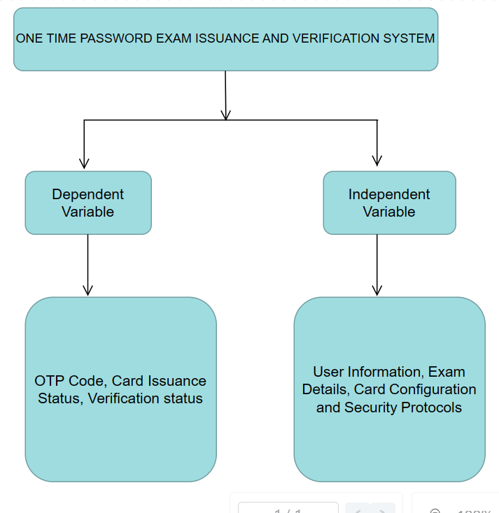

**Figure 1.** *Concept Map*

# CHAPTER THREE

# RESEARCH METHODOLOGY

# 3.0 INTRODUCTION

This chapter discussed the research designs and how they were employed in this research. The development, implementation and evaluation of the model were also discussed. Finally, this chapter outlined the various considerations that guided the study.

Top of Form

# 3.3 RESEARCH METHODOLOGY

For the design of the platform, waterfall methodology was proposed. In software development, waterfall describes a phased progression of activities. This linear and sequential approach allowed the breaking of the project into understandable and explainable phases with clearly defined deliverables. The team only proceeded to the next phase only when the previous phase was completed and everything approved.

## 3.3.1 Six Stages of the Waterfall Software Development Life Cycle

The process itself can be divided into different phases, depending on the IT project or other product development requirements.

Requirements

Testing

Coding

Design

Analysis

Implementation

*Figure 2. Water Fall Model*

1. **Requirements**

In this stage, the development team methodically gathered project requirements. Users gave the analyst their expectations then the analyst gathered what was required to achieve the goal. Well- documented requirements served a foundation and guaranteed a smooth software development process.

1. **Analysis**

The functional and non-functional requirements were analyzed and project scope and constraints outlined. The phase was critical for obtaining a clear vision of the product. The current system was analyzed using data flow diagrams.

1. **Design**

Using the output from the previous stage, the system’s design proceeds, including the software and hardware architecture, database tables and user interface mockups. Normalization was done.

1. **Coding**

Once the design was approved, actual coding commenced according to the project specifications. The coding process runs smoothly if the project design phase has been properly executed.

1. **Testing**

During this stage, all testing activities including functional, system and acceptance testing to find bugs, errors or flaws were performed. Testers also made sure that the product was built as per the requirements specification and that it functioned as required. Any bugs found in the software meant going back to the coding stage to fix them.

1. **Implementation**

Is the operations phase. This was the final stage of the software development life cycle that covered the software deployment to a live environment. It also included maintenance of the subsequent support of the product to ensure it functioned properly at all times.

## 3.3.3 Justification

The waterfall model was appropriately chosen and used for this study due it predictable nature and reliability. Although it was a bit costly, it is simply understood and easy to managed due to rigidity. Each phase had specific deliverables and a review process and there is clearly defined stages.

## 3.3.4 Conclusion

Like any other methodology, the waterfall software development model worked best when put in the right context. With its inherent stability and linear development process, it was a viable option for the projects with a fixed scope, a strict budget and clear-cut requirements.

# 3.2 DATA COLLECTION

Questionnaires were the dominant primary data collection method in the study. Self-administered questionnaires were the main instrument in the study. This was designed to gather information and explore the key variables addressed to the student and examination management team on the use of exam card distribution and identity verifications. Both open and closed ended questionnaires were used to let respondents give their own opinion concerning the research questions outlined above. Data was collected through interviews made to quite a number of students and the examination service providers in Kabarak University. This involved both formal and informal interviews where the respondent interviews involved students and the examination service providers in Kabarak university. To increase the response personal interviews were conducted so that translation and interpretation of the interviews would help guide the respondent give the right response. Closed ended questionnaires were issued randomly across the sampled bit of the population in Kabarak university so as to obtain a non-participant view of the research study.

# 3.4 TESTING

## 3.4.1 Heuristic Evaluation

This is a usability inspection method for computer software that helps scrutinize issues in the design of the user interface. It involves evaluators checking the interface and judging its compliance with the set known usability guides. It is conducted in many ways dependent on the scope and type of project.

Advantages

It provides good feedback on areas that need to be improved.

Disadvantages

Relies on a specific set of criterions and thus dependent on the judgement of those who evaluate it.

Is both an individual and a group process as it must start individually before aggregating results so as to reduce group confirmation bias.

request.

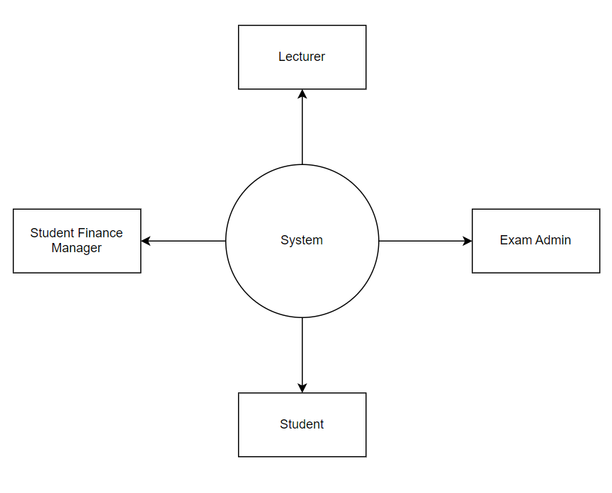

***Figure 3.*** *Context Map*

## DESIGN DIAGRAMS

## 3.5 Context Diagram

## 3.5.1 DATA FLOW DIAGRAM

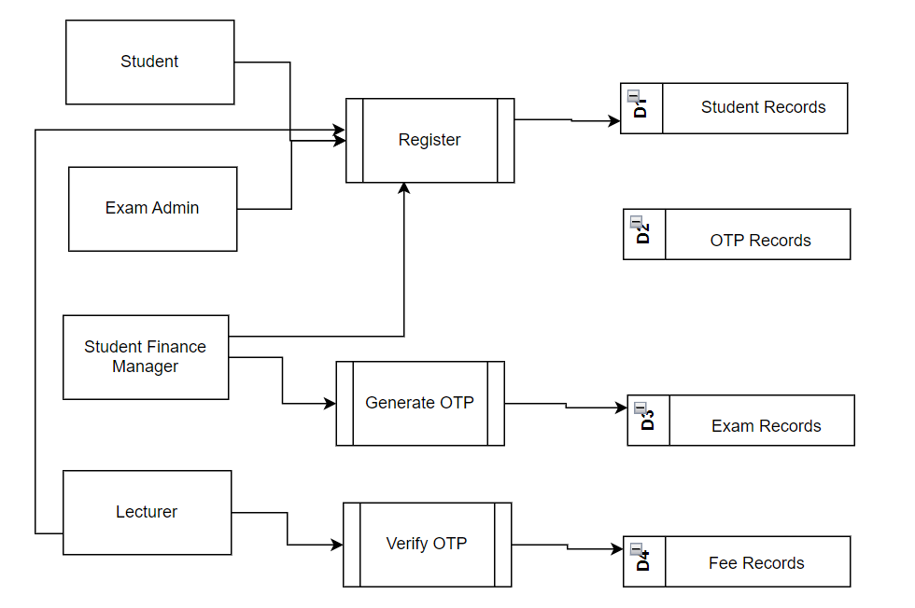

***Figure 4*.** *Level 1 Data Flow Diagram*

**3.5.2 USE CASE DIAGRAM**

OTP EXAM CODE VERIFICATION SYSTEM

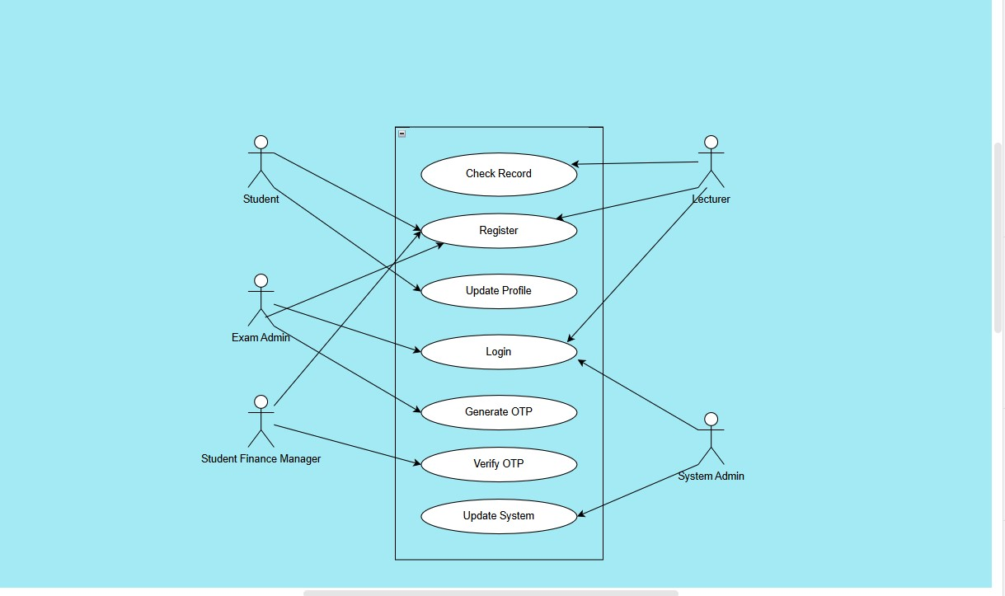

***Figure 5.*** *Use Case*

# 3.5.3 RESEARCH ETHICS

Research ethics are crucial in ensuring that studies involving human participants are conducted with integrity, respect, and adherence to moral principles. When conducting this research for the above mentioned system, I observed various issues related to participant confidentiality. Below are some research ethics focusing on confidentiality:

**Informed Consent:**

Consent was obtained from participants, explaining the purpose, procedures, and potential risks of the research and clearly communicated the voluntary nature of participation and the right to withdraw at any stage without consequences.

**Anonymity and Confidentiality:**

I guaranteed the anonymity of participants by avoiding the collection of personally identifiable information where possible and also assured participants that any collected data would be treated with confidentially, and no individual responses will be disclosed without explicit consent.

**Data Handling Procedures:**

Clear procedures for handling and transferring data to minimize the risk of data breaches were established. Access to the data was only limited to authorized research personnel who were well trained on ethical data handling practices.

**De-identification Techniques:**

De-identification techniques such as coding or pseudonyms were utilized to separate participant identities from their responses. All presentation of findings excluded the inclusion of personally identifiable information.

**Communication with Participants:**

An open communication was maintained with participants throughout the research process, addressing any concerns they may have regarding confidentiality. There was also a mechanism for participants to contact the researcher with questions or concerns about their involvement in the study.

**Ethics Committee Approval:**

An approval was sought from Kabarak Institutional Review Board (KIRB) before commencing the research to ensure that the study met ethical standards.

All the requirements specified by the (KIRB) were adhered to during research regarding participant confidentiality.

**Continuous Monitoring:**

There will always be regular review and update on security measures to adapt to changing technologies and potential risks in future. Similarly, periodic audits to ensure ongoing compliance with ethical standards will be conducted, especially regarding participant confidentiality.

To sum up, the incorporation of these ethical considerations into the OTP Exam Card system research, has contributed to the responsible and respectful treatment of participants, maintaining the trust and integrity of the research process.

# CHAPTER FOUR

# Introduction

In Chapter Four, we delve into the pivotal phase of developing the OTP Examination Verification System and deployment, we will transform the blueprint of our proposal into tangible outcomes. This chapter outlines the structured approach we will take to turn our concept into reality, ensuring seamless execution and achievement of project objectives. From initial implementation strategies to the critical deployment milestones, we navigate the path towards successful project delivery.

1. Top of Form
2. Bottom of Form

# System Architecture

The system was designed to contain various layers as described below:

**Presentation Layer**: This layer consisted of the user interfaces for different stakeholders, including admin, police, and victims. Each user interface tailored to their specific needs, ensuring ease of use and efficient interaction with the system.

**Application Layer:** This layer contained the business logic and functionality of the system. It handled tasks such as user authentication, OTP generation, data processing, and communication between different components of the system.

**Data Layer:** This layer managed the storage and retrieval of data related to gender-based violence cases. It included a database to store information such as exam details, user profiles, OTP records, and exam records for analysis and retrieval purposes.

**Security Layer:** Given the sensitive nature of the data involved, a robust security layer was implemented to protect the confidentiality, integrity, and availability of information. This layer included measures such as encryption, access control, and audit logging to ensure compliance with privacy regulations and safeguard against unauthorized access or data breaches.

# Front End Development (code extract)

This code extract shows the front end design of the exam card application, kindly preview the html code below.

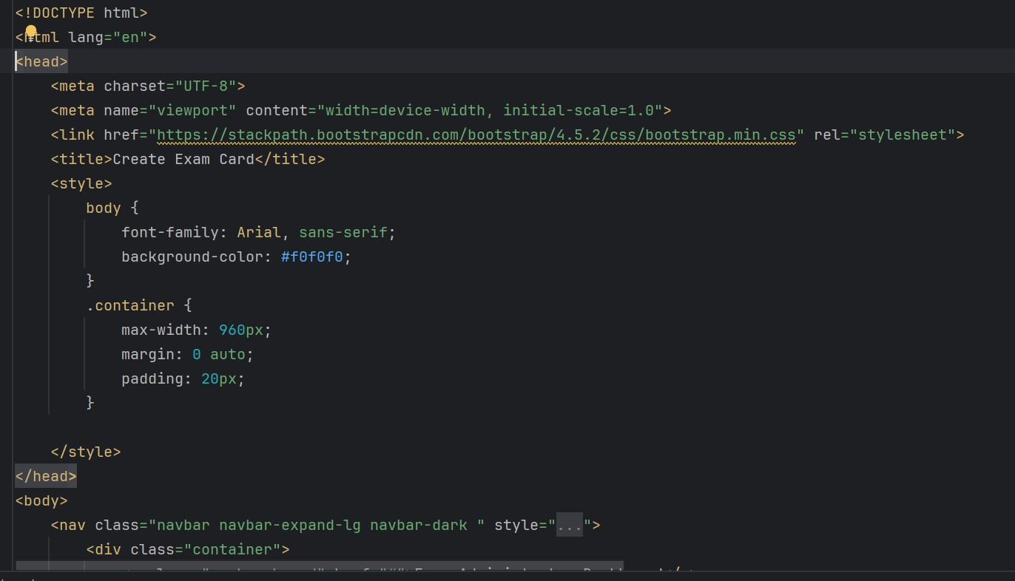

***Figure 6.*** *Exam card*

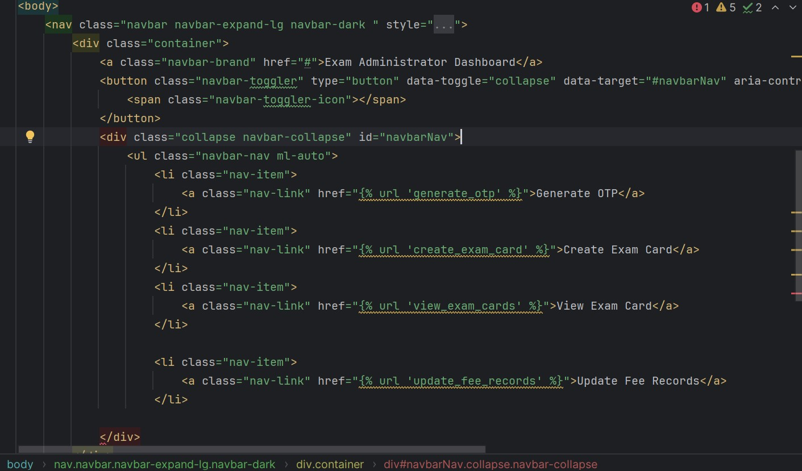

***Figure 7.*** *Exam card*

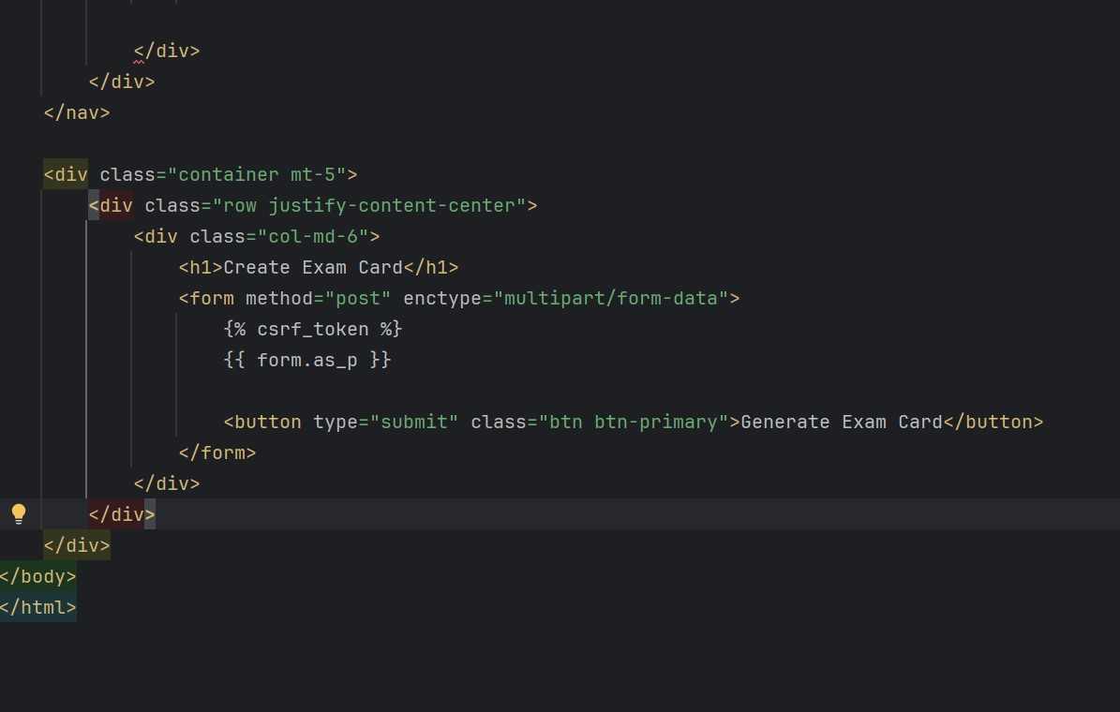

***Figure 8.*** *Exam Card*

These code extract is part of the Django OTP Exam card verification system and handles forms related to Registration form, exam card form, fee record form and one-time passwords (OTPs). (Views.py)

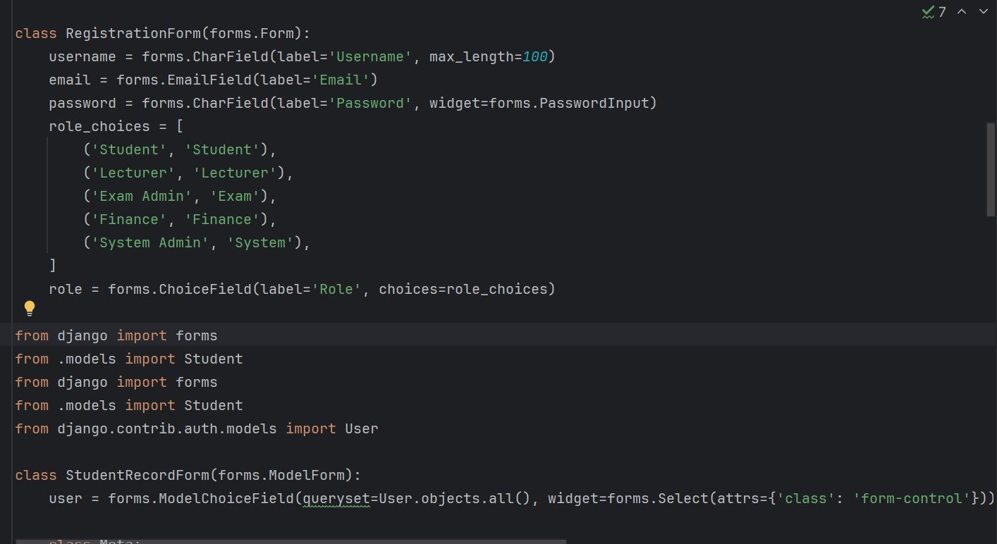

***Figure. 9*** *Registration Form*

# User Interface Design

The image below shows an interface design that displays how a student (user) of the OTP Exam card verification interacts with the system. From the image the student can log into the student dashboard after registration and update profile.

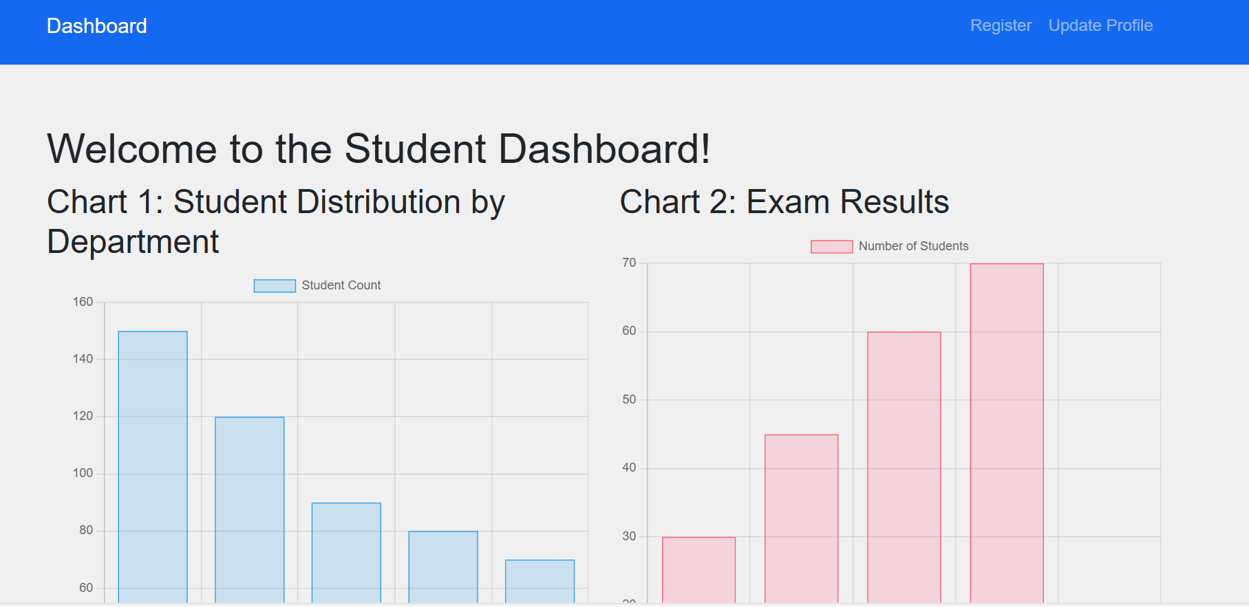

***Figure. 10*** *User interface*

# User Interface Modules (screen shot &explanation

The image below displays how the exam administrator can interact with the system can generate OTP, create exam cards, view exam cards and update fee records.

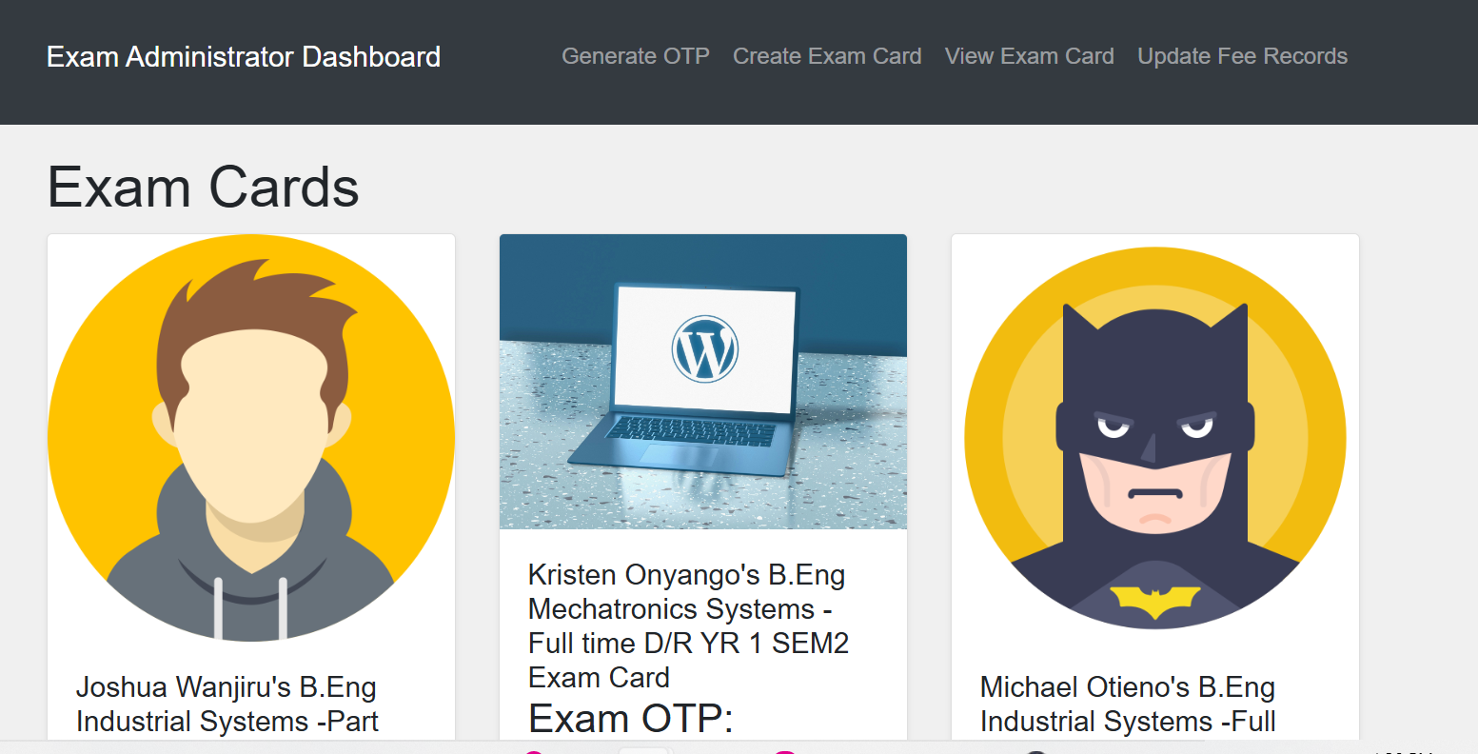

***Figure. 11*** *Exam Admin dashboard*

The image below displays how the student can register into the system and update their details

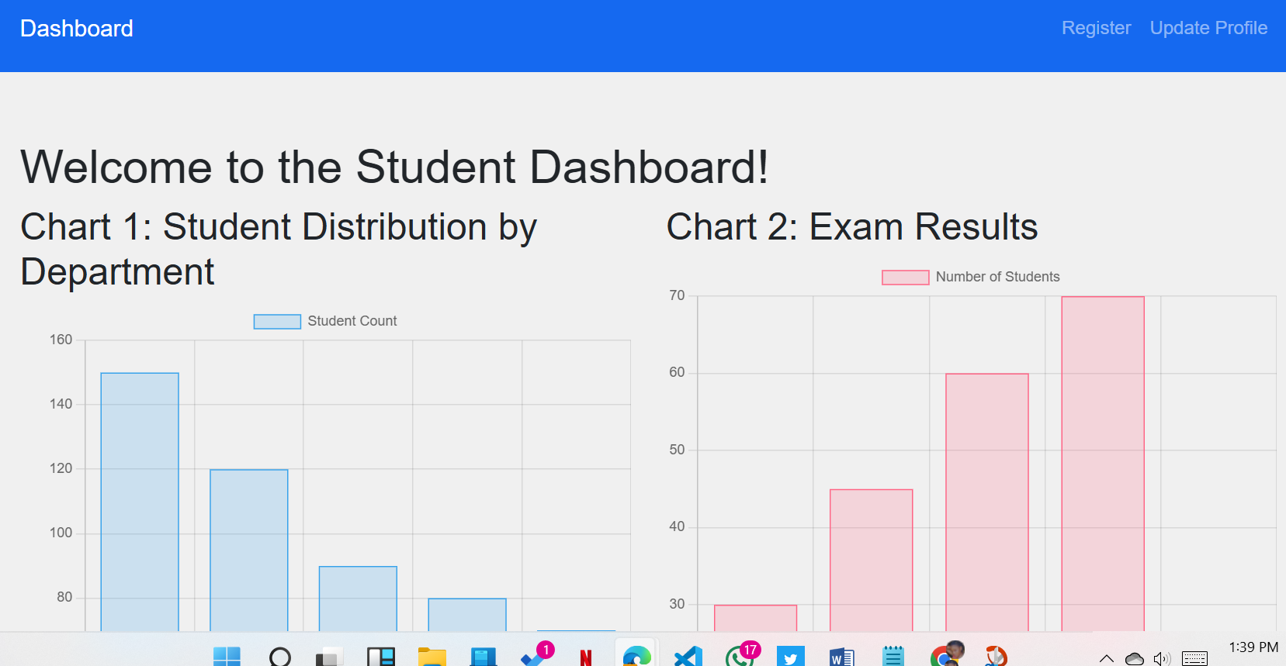

***Figure. 12*** *Student Dashboard*

The image below is user interface that allows lecturer as a user to view the student and other records concerning exam details.

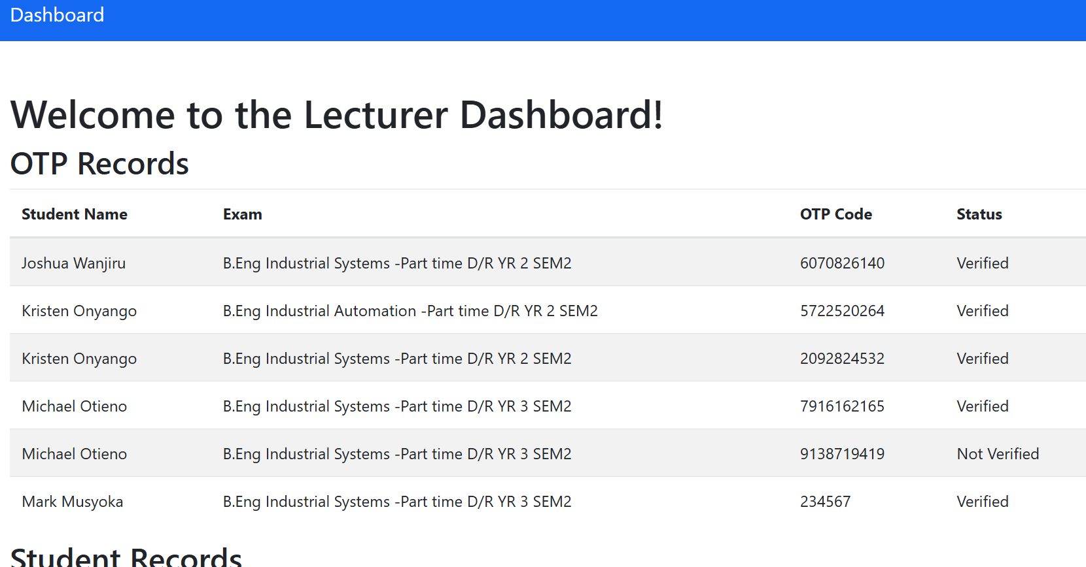

***Figure. 13*** *Lecturer dashboard*

# Back End Development

The code snippet below allows customization of the Django admin interface for the OTP Exam card application.

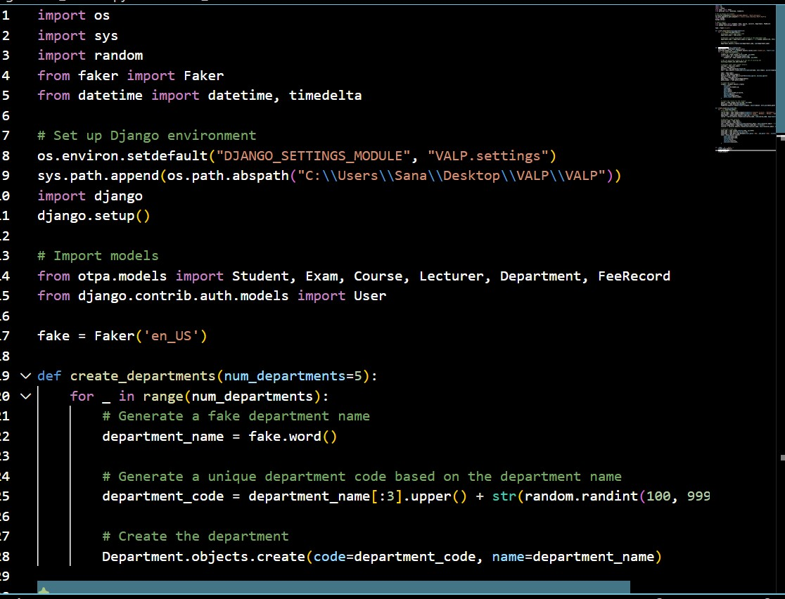

***Figure. 14*** *Back-end models*

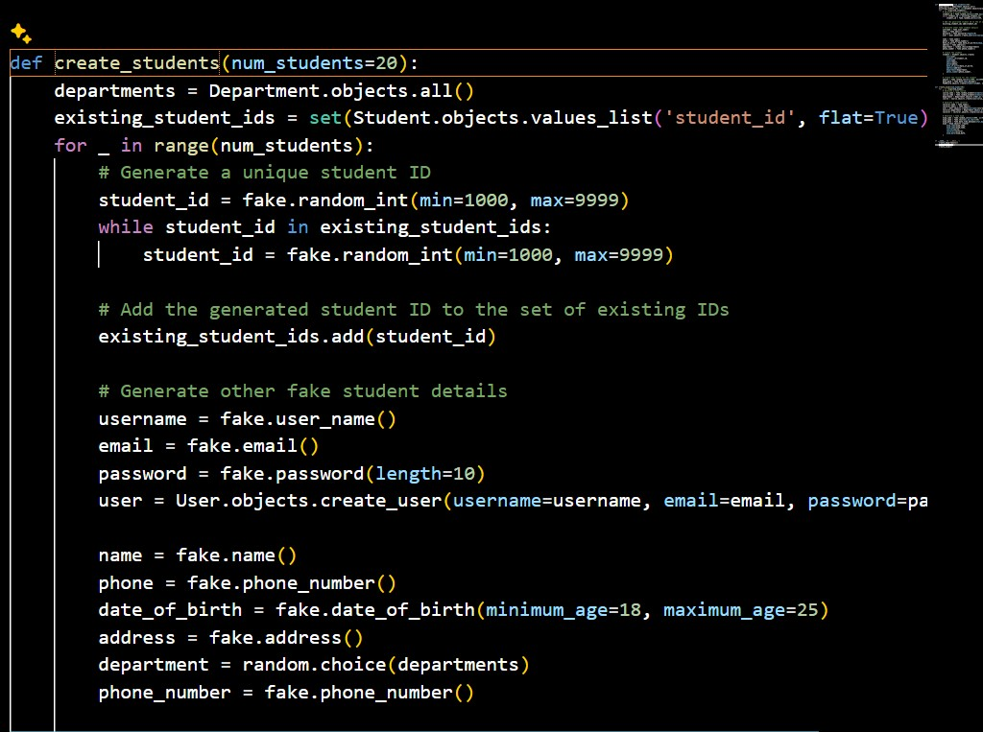

***Figure. 15*** *student ID*

The above code snippet generates unique student IDs, and adds the generated student ID to the set of existing IDs.

# Database Design Modules

The image below shows the database module for the course records.

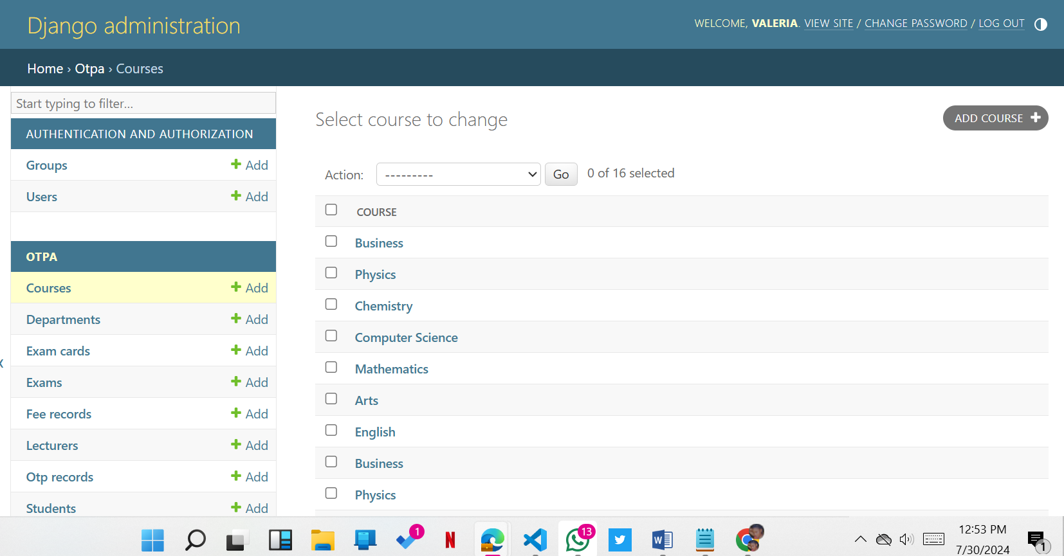

***Figure. 16*** *Courses*

# 3.1.3 Code Testing

## User Acceptance Testing

User Acceptance Testing was crucial to evaluating the application's usability and functionality from the perspective of end-users. It involved engaging individual representative of the target audience, including Students, Student Finance manager, examination administrators and lecturers in Kabarak University. The exam application was intuitive, accessible, and aligned with the needs of all the listed users.

## Scenario-Based Testing

This testing technique involved creating realistic usage scenarios to assess the application's response under various conditions. Scenarios included successful distribution of OTP codes to various student emails and clear display of their corresponding exam cards using the codes. Generated. By simulating real-world situations, this testing approach ensured that the application was effectively accessible.

## Security Testing

Given the sensitive nature of the information being handled (Student Examination Details), security testing was paramount. This technique evaluated the application's ability to protect user data, maintain confidentiality, and prevent unauthorized access. It included encryption assessment, secure data transmission, and resistance to common security threats to safeguard the privacy student examination and financial details.

## Performance Testing

Performance testing assessed the responsiveness, scalability, and reliability of the Web Application under different loads and usage patterns. This ensured that the application could handle varying levels of user activity and data input without compromising its speed or functionality, providing a seamless experience for all users.

## Acceptability Testing

Accessibility testing was crucial to ensuring that the OTP Web Application was inclusive and could be used by individuals with diverse abilities. This included testing for compatibility with assistive technologies, adherence to accessibility standards, and providing alternative options for users with different needs, such as visual or hearing impairments.

## Cross Platform Testing

To guarantee a consistent user experience, the OTP Web Application System was tested across various devices and operating systems. Cross-platform testing ensured that the application functioned seamlessly on different smartphones and tablets commonly used in Kabarak University, promoting widespread accessibility.

## Automated Testing

Automated testing involved the use of scripts and tools to execute repetitive and complex test scenarios. This approach accelerated the testing process, enhanced test coverage, and facilitated early identification of potential issues. Automated testing was particularly beneficial for routine checks, regression testing, and continuous integration.

# 3.1.4 Deployment Methods

**Environment Setup:**

Installation - to install and run the OTP Exam Code Verification System, follow these steps:

1. Install Python (version 3.x) from the [official Python website] (https://www.python.org/).

2. Install Django (version 3.x) by running the following command:

```

Python –m pip install Django

```

3. Install other dependencies using the following command:

```

pip install -r requirements.txt

```

steps to set up a virtual environment:

Install virtual environment using:

```

python-m install venv

```

Call the venv and name your project:

```

python –m venv OTPCodeproject

```

Activate the virtual environment:

```

Source OTPCodeproject/scripts/activate

```

**Database Setup:**

The system uses SQLite as its database. No additional setup is required for the database.

**Web Server Configuration:**

The project is using an ASGI (Asynchronous Server Gateway Interface) server. ASGI is designed for handling asynchronous web applications and is commonly used with servers like Daphne, Uvicorn, or Hypercorn.

**Deployment Strategies:**

Describe the deployment strategy used for the project, such as:

Manual deployment: Manually building and deploying the application to the production server.

Automated deployment: Using a continuous integration (CI) and continuous deployment (CD) tool like Jenkins, GitLab CI/CD, or GitHub Actions to automate the deployment process.

Provide the specific steps for each deployment strategy, including any necessary scripts or configuration files.

**Static File Handling:**

Explain how static files (CSS, JavaScript, images, etc.) are handled in the production environment, such as using a content delivery network (CDN) or a web server like Nginx to serve the static files.

Include the steps to collect and configure the static files for production.

**Environment Configuration:**

Describe how the production environment is configured, including the use of environment variables for sensitive information (e.g., database credentials, secret keys).

Provide instructions on how to set up the production environment configuration.

**Monitoring and Logging:**

Outline the tools or services used for monitoring the application, such as application performance monitoring (APM) tools, log management solutions, or error tracking platforms.

Explain how to set up and configure the monitoring and logging for the production environment.

**Scaling and High Availability:**

If applicable, describe how the application can be scaled to handle increased traffic, such as utilizing load balancers, horizontal scaling, or containerization.

Provide guidance on how to set up a high-availability (HA) environment for the Django application, if required.

**Security Considerations:**

Highlight any security-related configurations or best practices, such as SSL/TLS setup, CSRF protection, or securing the Django admin interface.

**Disaster Recovery and Backups:**

Explain the backup strategy for the application, including the database, static files, and any other critical components.

Provide instructions on how to restore the application from a backup in the event of a disaster or data loss.

# CHAPTER FIVE

# Conclusion and future work

## Conclusion

Building an OTP Exam card issuance system can be a complex and challenging process, requiring careful planning, design, development, testing, and deployment. However, with the right strategy and approach, it was possible to create a successful web-based system that meets the needs of the listed relevant system beneficiaries/users such as the student and the higher learning institutions. The development process requires close collaboration between stakeholders, including developers, designers, project managers, and business analysts, to ensure that the system meets the requirements and specifications set out during the planning and design phases. This collaboration led to a successful innovation of this system.

# 

# REFERENCES

Lamport. L. “Nowadays, there are many patented OTP tokens” 1980, pp. 125-140. Retrieval of Student Information Via Code. Volume 2, issue 1.

Kinjal, H., Hiren J. A survey on QR Codes: in context of Research and Apllication. International Journal of Emerging Technology and Advanced Engneering (*ISSN 2250- 2459, ISO 9001:2008 Certified Journal*, Volume 4, Issue 3, March 2014.

Falguni, P., 2015. QR Code Approach for Examination Process. Report 1615 RP. Atlanta, GA: ASHRAE.

Behfar, A., D.P. Yuill, and Y. Yu. 2017. Automated fault detection and diagnosis methods for OTP Generation Systems(RP-1615). *Science and Technology* 23(8):1253–66.

De Vaus, DA. Research design in social research. London: SAGE, 2001; Research Methodology in Social Sciences (A Short Manual) (pp.175). 2020.

Trochim, William M.K.2021). Research methods knowledge base Research Volume 4 issue 3, pp. 303–18.

 Jung, I., Heon, Y., Enhanced security for online exams using group cryptography

*IEEE Trans. Educ*., 52 (3) (2009), pp. 340-349

Adsul, A., Gayatri, K., Bankar, A., B., Automated Examination Process using QR Code Technology. *Computer Science.* (2014), pp. 167-179

Shah, K., Shah, S., 2017. Secure Examination System Using Biometric and QR Code Technology.

Saidivya, A., Bhargari, M., 2014. OTP-Based Electronic Protection System for Exam Paper Leakage. Unique paper ID: 159678 Publication Volume & Issue: Volume 9, Issue 12 Pages(s):661-666

Kinyan, J., Saplah, Y., 2009. An Advanced and Secure Framework for Conducting Online Examination Using Blockchain method. Pp. 1-37. Vol.1.

Jacksi, K., Mohammed, F., Zebari, S., February 2018. International Journal of Engneering and Technology, 6(2):49-53

# APPENDICES

Questionnaire administered to students:

**Demographic Information:**

a. Name (optional):

b. Age:

c. Gender:

d. Academic Program:

Experience with OTP System: a. Have you used the OTP code distribution system during exams?

Yes

No

b. How would you rate your overall experience with the OTP system?

Very Satisfactory

Satisfactory

Neutral

Unsatisfactory

Very Unsatisfactory

**Ease of Use**:

a. How easy was it to receive and input the OTP codes during exams?

Very Easy

Easy

Neutral

Difficult

Very Difficult

b. Were there any challenges or difficulties you faced while using the OTP system? Please describe.

**Security and Confidence**:

a. How confident are you in the security provided by the OTP system for exam authentication?

Very Confident

Confident

Neutral

Not Confident

Not Confident at All

b. Do you have any concerns about the security of the OTP system? If yes, please specify.

**Suggestions for Improvement:**

* 1. What improvements or additional features would you suggest for the OTP code distribution system?

**Questionnaire for Examination Providers:**

Demographic Information:

a. Name of Institution/Organization:

b. Your Role/Position:

c. Number of Exams Conducted Annually:

**Implementation and Integration:**

a. How smoothly was the implementation of the OTP code distribution system into the exam process?

Very Smooth

Smooth

Neutral

Challenging

Very Challenging

b. Were there any technical or logistical challenges encountered during the integration of the OTP system? Please elaborate.

**System Performance:**

a. How would you rate the performance and reliability of the OTP system during exams?

Excellent

Good

Fair

Poor

Very Poor

b. Were there any instances of system failures or downtime during exams? If yes, please describe.

**Feedback from Students:**

a. Have you received any feedback from students regarding their experience with the OTP system? If yes, please summarize.

**Improvements and Enhancements:**

a. What improvements or enhancements do you believe could be made to the OTP code distribution system to better serve the needs of the examination process?

**Overall Satisfaction:**

a. How satisfied are you with the overall performance and effectiveness of the OTP system in ensuring exam security?

Very Satisfied

Satisfied

Neutral

Unsatisfied

Very Unsatisfied